NORTHWESTERN CHAPTER NARGS: Gift Membership Form

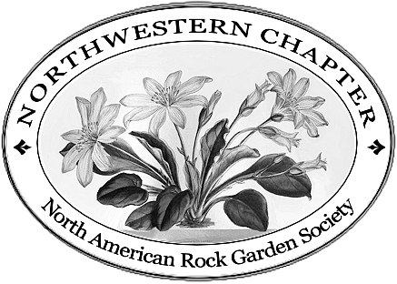 | Please send this form with a check for $15 made out to: Northwestern Chapter NARGS Send to:  NARGS Treasurer  Mari Short  18232 36th Avenue West #G7  Lynnwood, WA 98037-3882

I would like to give a gift membership to the following special person or persons ($15 membership includes two individuals at the same address).

Send gift notice by: [ ] email [ ] postal service

Date______________________ (Payment after 4/1 is good through 9/1 next year.)

Recipient's Name __________________________________________________

Recipient's Address__________________________________________________________

City________________________________State___Zip____________________

Recipient's Phone(s)_________________________________________________________

Recipient's Email(s)__________________________________________________________

Message to be included with gift notification:

________________________________________________________________

________________________________________________________________

________________________________________________________________

Purchaser’s Name __________________________________________________

Purchaser’s Address__________________________________________________________

City________________________________State___Zip____________________

Purchaser’s Phone(s)_________________________________________________________

Purchaser’s Email(s)__________________________________________________________

Would you like to purchase a membership for yourself as well? [ ] Yes [ ] No
If so, please add $15 to your total.

